DATA ANALYSIS INTERNSHIP – DAY 12 REPORT
Organization: Top Tech Developers
Topic Covered: Matplotlib – Range Functions, Graph Types & Comparisons
On Day 12 of the internship, different graph plotting techniques and range control functions were practiced using Matplotlib in Google Colab. Various graph types, subplot techniques, and comparison charts were created to understand graphical representation and data visualization concepts.

Introduction
Matplotlib is a Python library used for data visualization. It helps represent numerical data in graphical form for analysis and understanding. Matplotlib supports different graph types and axis control functions which help customize plots effectively.
Import Statement
import matplotlib.pyplot as plt
import random
import numpy as np
Explanation
- matplotlib.pyplot → Used for graph plotting
- random → Used to generate random values
- numpy → Used for mathematical operations

Task 1 – Range Functions in Matplotlib
Different range control functions were practiced to customize graph axes.
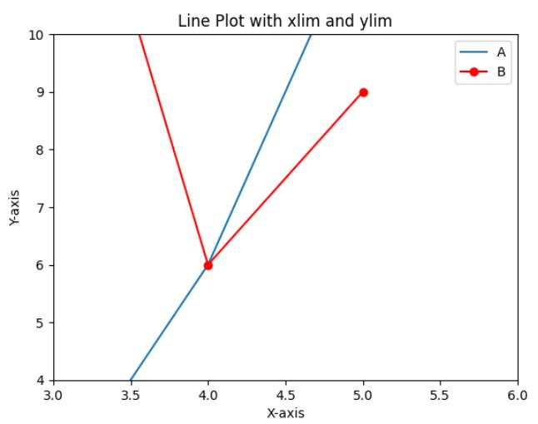
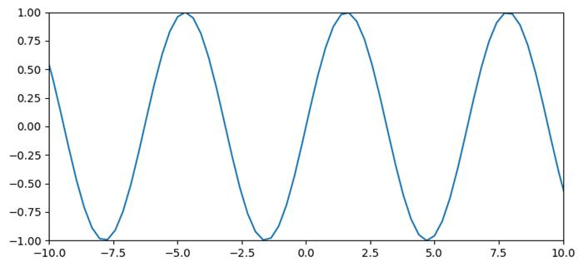
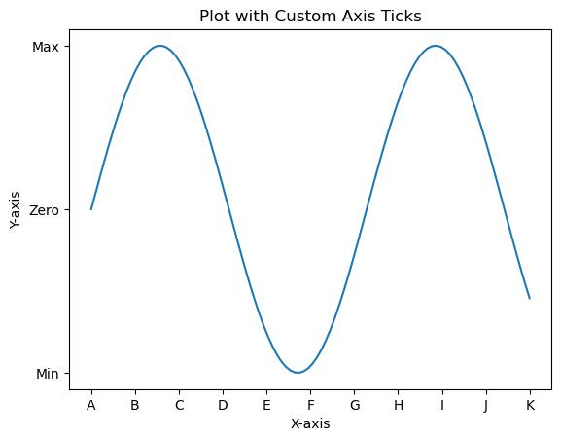
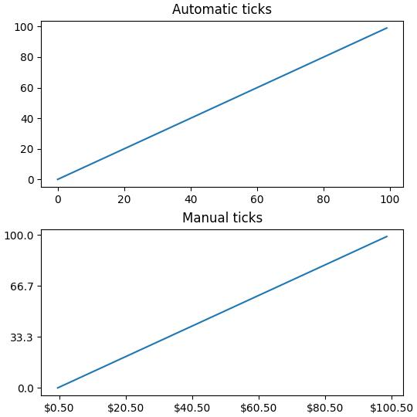
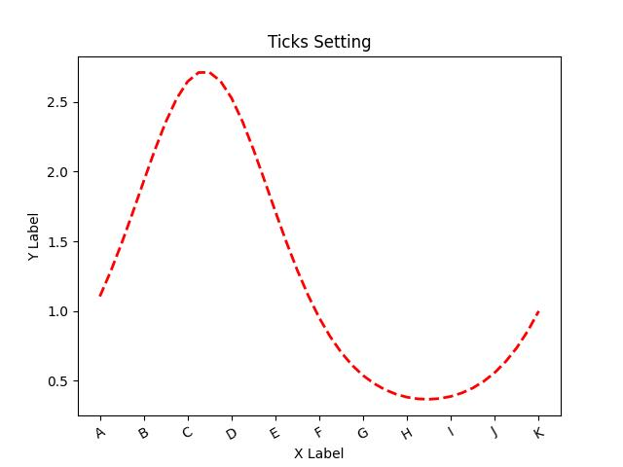

1. Using plt.xlim() and plt.ylim()
Program
plt.plot(x,y)

plt.xlim(0,10)
plt.ylim(0,60)
Purpose
- Controls X-axis and Y-axis range separately
- Used for zoom in and zoom out effects
Observation
- Helps focus on specific graph areas.
- Improves graph readability.

2. Using plt.axis()
Program
plt.plot(x,y)

plt.axis([0,10,0,60])
Purpose
- Sets both X and Y axis range in one line
- Format: [xmin, xmax, ymin, ymax]
Observation
- Simplifies axis range control.
- Useful for quick graph customization.

3. Using plt.xticks() and plt.yticks()
Program
plt.xticks([0,2,4,6,8,10])
plt.yticks([0,10,20,30,40,50,60])
Purpose
- Controls tick values shown on axes
- Helps customize scale display
Observation
- Tick customization improves graph clarity.
- Makes numerical interpretation easier.

Task 2 – Subplot (2 Graphs in One Figure)
Subplots were used to display multiple graphs in a single figure window.
Program
plt.subplot(1,2,1)
plt.plot(x,y)

plt.subplot(1,2,2)
plt.bar(a,b)
Purpose
- Displays multiple graphs in one window
- Format: rows, columns, position
Observation
- Subplots help compare graphs side by side.
- Useful for multi-data analysis.

Task 3 – Sin and Cos Multiplication Graph
A mathematical visualization graph was created using sine and cosine functions.
genui{"math_block_widget_always_prefetch_v2":{"content":"y=x\sin(x)"}}
genui{"math_block_widget_always_prefetch_v2":{"content":"y=x\cos(x)"}}
Program
x = random.randint(1,50)
y = random.randint(1,50)

a = x * np.sin(x)
b = y * np.cos(y)

plt.plot(a,b,"o")
Purpose
- Generates mathematical patterns using sin and cos
- Used for scientific visualization
Observation
- Mathematical functions create unique graph patterns.
- Useful for scientific and analytical plotting.

Task 4 – Different Graph Types
Different graph plotting techniques were practiced using Matplotlib.
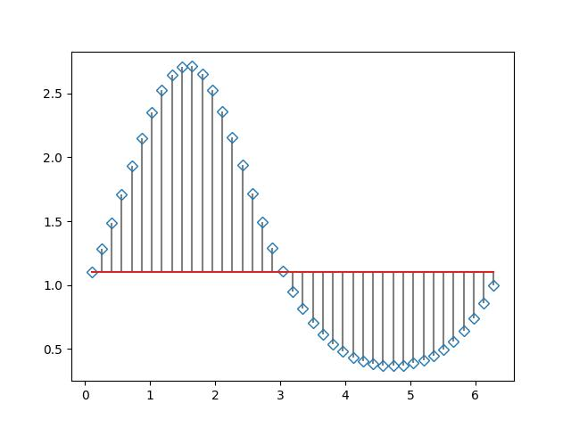
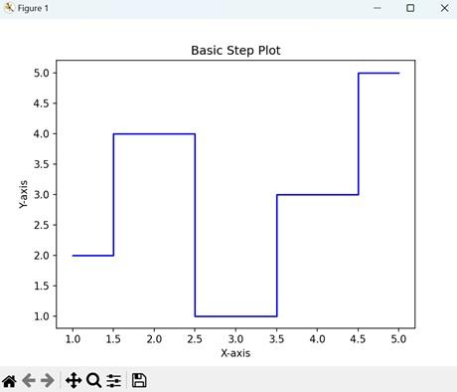
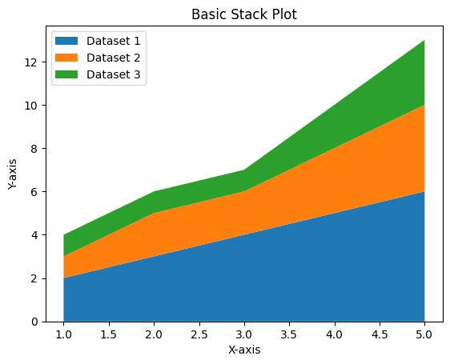
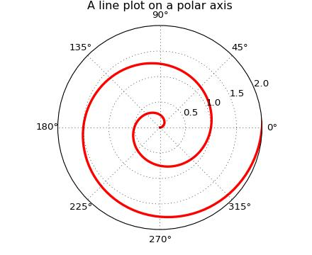
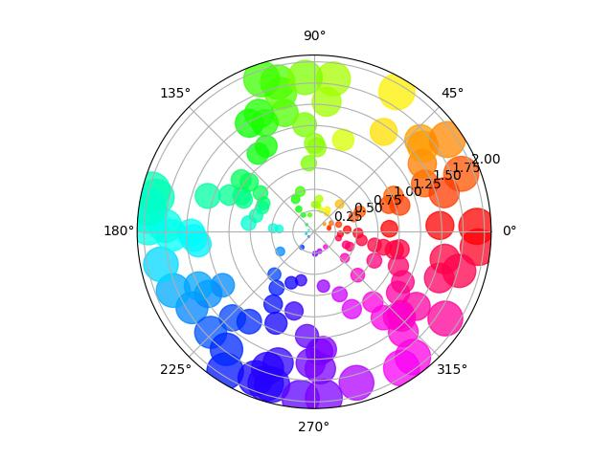
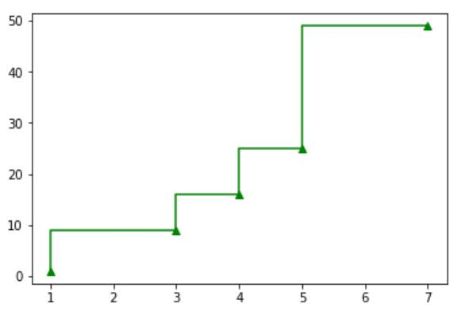

1. Stem Plot
Program
import matplotlib.pyplot as plt

x = [1,2,3,4,5,6,7]
y = [10,25,15,40,30,50,45]

plt.stem(x,y)
plt.title("Stem Plot")

plt.show()
Purpose
- Displays discrete data values using vertical stems.

2. Step Graph
Program
plt.step(x,y)
Purpose
- Displays step-wise data changes.

3. Area Graph
Program
plt.fill_between(x,y)
Purpose
- Shows filled area under the curve.

4. Stack Plot
Program
plt.stackplot(x,y1,y2)
Purpose
- Shows multiple datasets stacked together.

5. Polar Graph
Program
plt.polar(x,y)
Purpose
- Used for circular and angular data visualization.

6. Pie Chart
Program
import matplotlib.pyplot as plt

values = [20,30,25,25]
labels = ["A","B","C","D"]

plt.pie(values, labels=labels)
plt.title("Pie Chart")

plt.show()
Purpose
- Displays percentage distribution visually.

Task 5 – Comparison of X vs Y and X vs Z
Comparison graphs were created using line and bar charts.
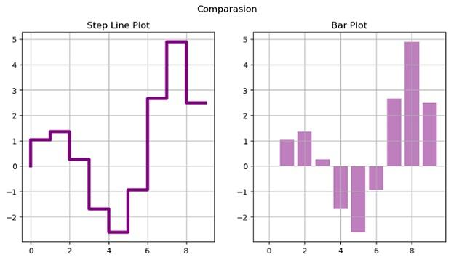
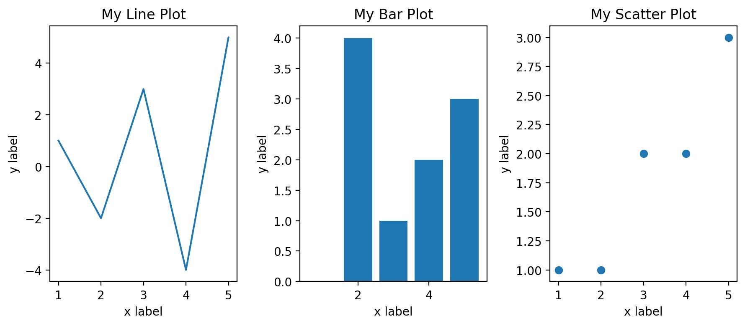
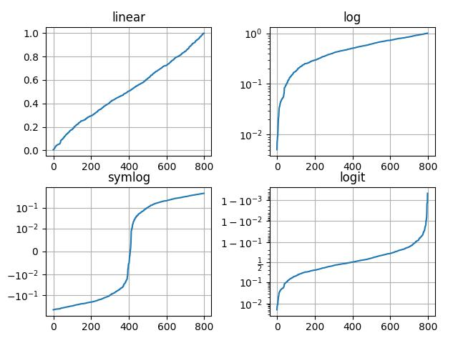
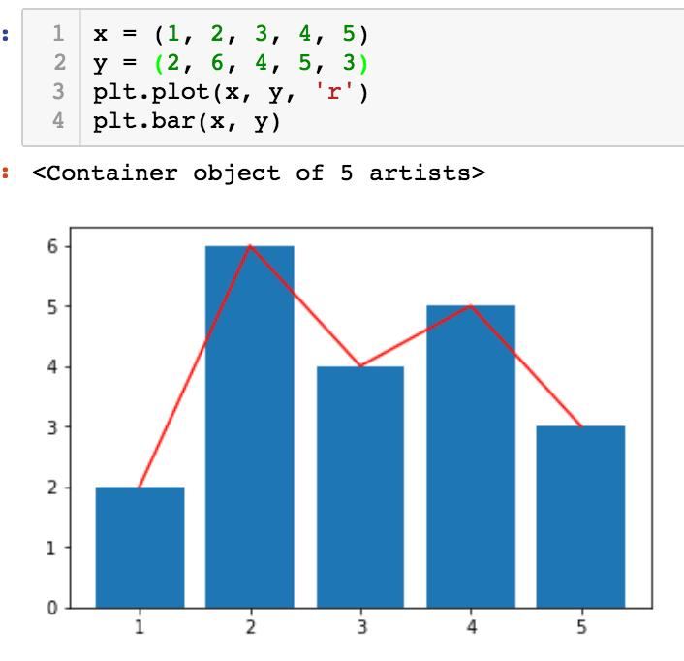
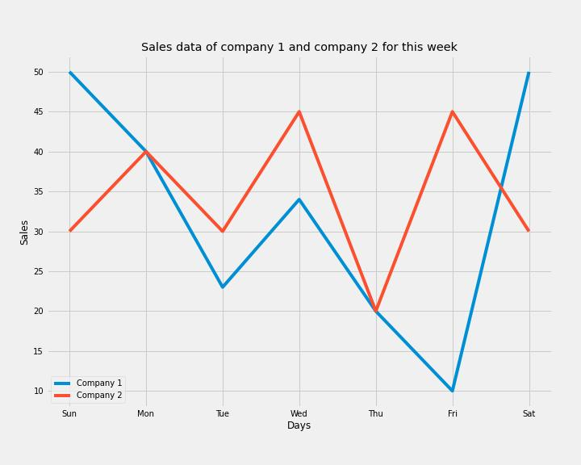
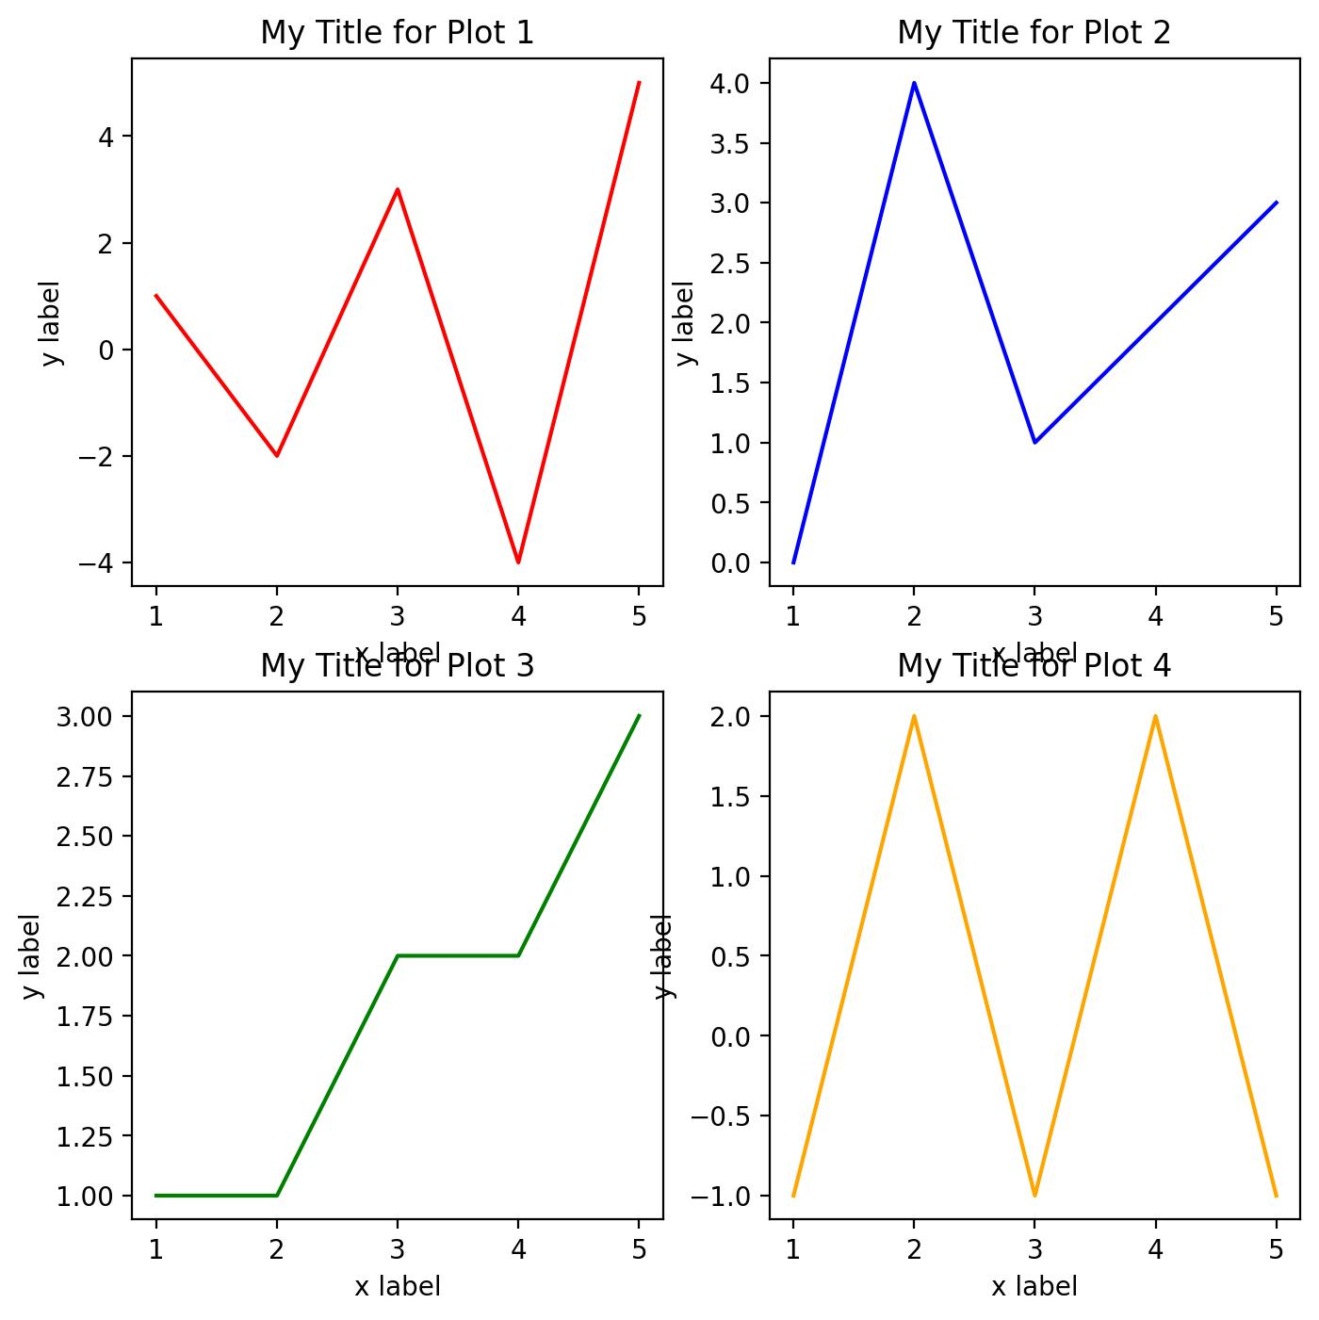
Program
import matplotlib.pyplot as plt

x1 = [1,2,3,4,5]
y1 = [10,20,30,40,50]
z1 = [15,25,35,45,55]

plt.subplot(1,2,1)
plt.plot(x1,y1,label="X1 vs Y1")
plt.title("Line Chart")
plt.legend()

plt.subplot(1,2,2)
plt.bar(x1,z1,label="X1 vs Z1")
plt.title("Bar Chart")
plt.legend()

plt.show()
Purpose
- Compares two datasets
- One comparison uses line graph
- Another comparison uses bar graph
Observation
- Comparison graphs help identify differences clearly.
- Useful for performance and trend analysis.

Technologies Used
- Python
- Matplotlib
- NumPy
- Google Colab
- Data Visualization

Learning Outcome
On Day 12, I learned different graph plotting and customization techniques using Matplotlib.
I understood:
- how to control graph ranges using xlim, ylim, and axis
- how to customize tick values
- how to create multiple graphs using subplot
- how mathematical functions generate graph patterns
- how to create stem, step, area, stack, and polar graphs
- how comparison graphs help analyze datasets visually

Conclusion
The Day 12 internship session helped me understand advanced graph plotting techniques using Matplotlib. I practiced different range control functions such as xlim, ylim, axis, xticks, and yticks for graph customization.
Additionally, I created multiple graph types including stem plots, step graphs, area graphs, stack plots, polar graphs, and comparison charts. This session improved my understanding of multi-graph visualization and graphical analysis techniques in Python.

